Ray Intersecting a Plane
# Source: AI Source: Provided by: [Data Path: Persons Table -> ID Column: 1, Name_En Column: Motasem Essam] -> From: [ChatGPT] on [7/25/2026]
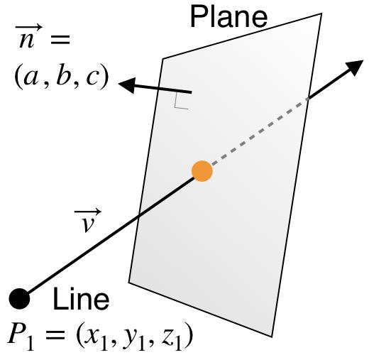
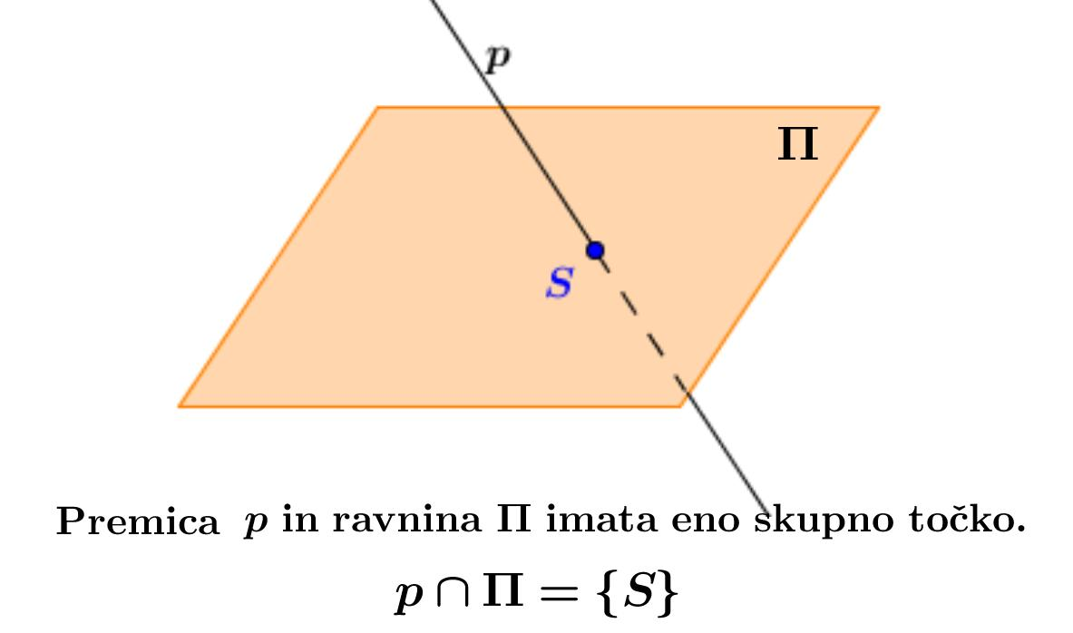
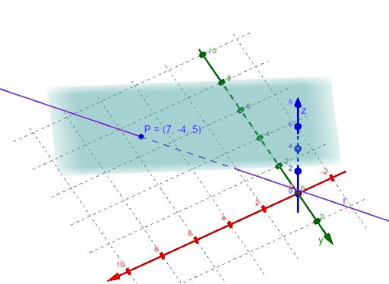

Definition
# Source: AI Source: Provided by: [Data Path: Persons Table -> ID Column: 1, Name_En Column: Motasem Essam] -> From: [ChatGPT] on [7/25/2026]
A ray intersecting a plane is a ray in three-dimensional space that meets a plane at a point. The ray and the plane share at least one point, called the point of intersection.
In the usual case, when the ray is not parallel to the plane and does not lie entirely within it, the ray intersects the plane at exactly one point.
For example, a ray traveling downward from a point above a horizontal plane may pass through the plane at point $P$ and continue below it.
The intersection point belongs to both the ray and the plane.

Simple definition
# Source: AI Source: Provided by: [Data Path: Persons Table -> ID Column: 1, Name_En Column: Motasem Essam] -> From: [ChatGPT] on [7/25/2026]
A ray intersecting a plane is a straight path that starts at one point and meets a flat surface at a point.
The ray crosses the plane at point $P$.

Key characteristics
# Source: AI Source: Provided by: [Data Path: Persons Table -> ID Column: 1, Name_En Column: Motasem Essam] -> From: [ChatGPT] on [7/25/2026]
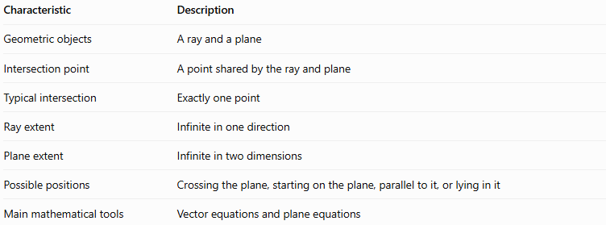
Characteristic | Description
Geometric objects | A ray and a plane
Intersection point | A point shared by the ray and plane
Typical intersection | Exactly one point
Ray extent | Infinite in one direction
Plane extent | Infinite in two dimensions
Possible positions | Crossing the plane, starting on the plane, parallel to it, or lying in it
Main mathematical tools | Vector equations and plane equations
A ray does not always intersect a plane at exactly one point. It can be parallel to and outside the plane, or it can lie entirely within the plane. These cases must be distinguished.

5. Types of ray-plane relationships

A. Ray crossing a plane at an interior point
# Source: AI Source: Provided by: [Data Path: Persons Table -> ID Column: 1, Name_En Column: Motasem Essam] -> From: [ChatGPT] on [7/25/2026]
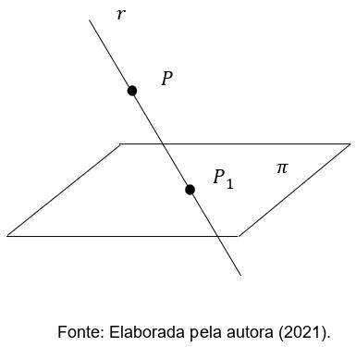
The ray crosses the plane at a point other than its endpoint.
The ray has points on both sides of the plane, and the plane intersects it at exactly one point.
Example: A ray begins above a horizontal plane and travels downward through it.

B. Ray beginning on a plane and moving away from it
# Source: AI Source: Provided by: [Data Path: Persons Table -> ID Column: 1, Name_En Column: Motasem Essam] -> From: [ChatGPT] on [7/25/2026]
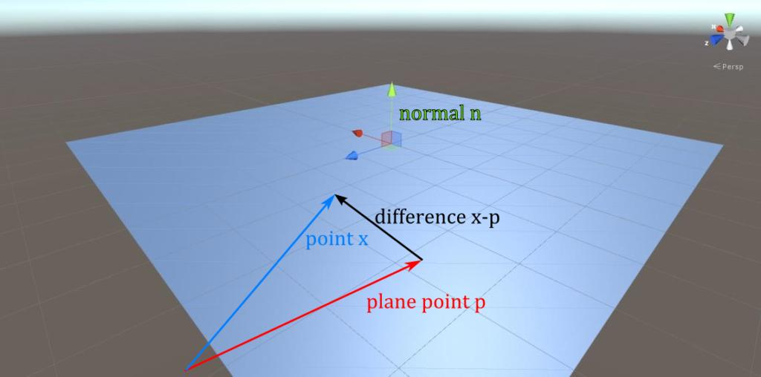
The endpoint of the ray lies on the plane, but the ray's direction takes it away from the plane.
In this case, the ray and plane share exactly one point: the endpoint.
Example: A ray starts on the floor and points vertically upward.

C. Ray beginning on a plane and crossing through it
# Source: AI Source: Provided by: [Data Path: Persons Table -> ID Column: 1, Name_En Column: Motasem Essam] -> From: [ChatGPT] on [7/25/2026]
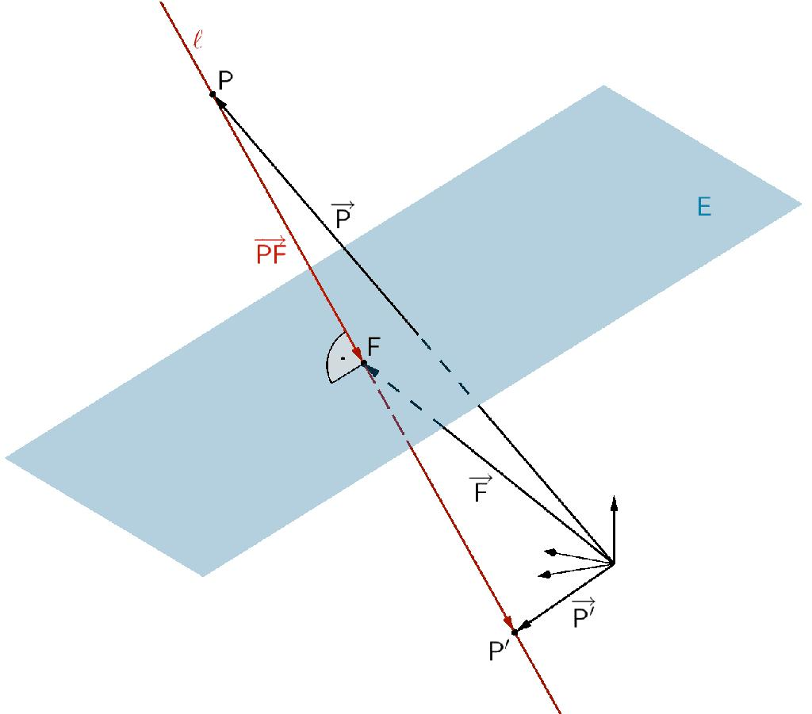
A ray can begin at a point on the plane and point into the side opposite the side from which it is considered to approach.
Since the endpoint lies on the plane, the ray-plane intersection is the endpoint itself. The ray does not cross to both sides after starting there; it extends only in its chosen direction.

D. Ray parallel to a plane
# Source: AI Source: Provided by: [Data Path: Persons Table -> ID Column: 1, Name_En Column: Motasem Essam] -> From: [ChatGPT] on [7/25/2026]
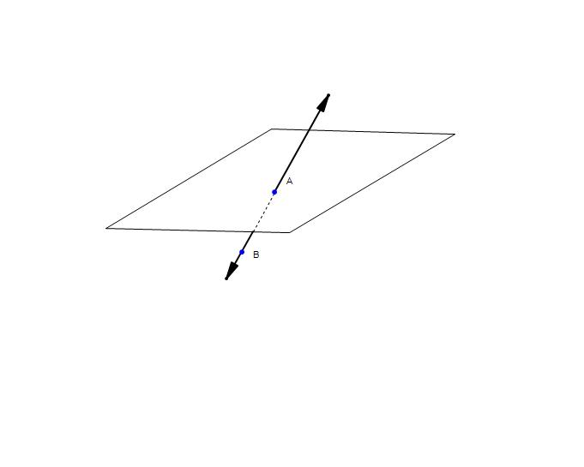
If the ray's direction is parallel to the plane and its endpoint is not on the plane, the ray never meets it.
Example: A ray travels horizontally at a fixed height above a horizontal plane.

E. Ray lying entirely in a plane
# Source: AI Source: Provided by: [Data Path: Persons Table -> ID Column: 1, Name_En Column: Motasem Essam] -> From: [ChatGPT] on [7/25/2026]
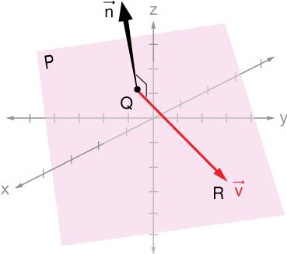
If the endpoint belongs to the plane and the ray's direction is parallel to the plane, every point on the ray lies in the plane.
The intersection is not a single point: the entire ray is shared by the plane.

Mathematical representations

A. Equation of a plane
# Source: AI Source: Provided by: [Data Path: Persons Table -> ID Column: 1, Name_En Column: Motasem Essam] -> From: [ChatGPT] on [7/25/2026]
A plane in three-dimensional space can be represented by:
$$\boxed{ax+by+cz+d=0}$$
Its normal vector is:
$$n=\left(a,b,c\right)$$
The normal vector is perpendicular to the plane.

B. Vector equation of a ray
# Source: AI Source: Provided by: [Data Path: Persons Table -> ID Column: 1, Name_En Column: Motasem Essam] -> From: [ChatGPT] on [7/25/2026]
Let the ray start at point $A=\left(x_{0},y_{0},z_{0}\right)$ with a nonzero direction vector $v=\left(u,v,w\right)$.
The ray is:
$$\boxed{r\left(t\right)=A+tv, t≥0}$$
In coordinate form:
$$\begin{aligned}x&=x_{0}+ut \\ y&=y_{0}+vt t≥0 \\ z&=z_{0}+wt\end{aligned}$$

C. Finding the intersection point
# Source: AI Source: Provided by: [Data Path: Persons Table -> ID Column: 1, Name_En Column: Motasem Essam] -> From: [ChatGPT] on [7/25/2026]
Substitute the ray coordinates into the plane equation:
$$a\left(x_{0}+ut\right)+b\left(y_{0}+vt\right)+c\left(z_{0}+wt\right)+d=0$$
Collecting terms gives:
$$\boxed{t=-\frac{ax_{0}+by_{0}+cz_{0}+d}{au+bv+cw}}$$
This formula applies when $au+bv+cw≠0$.
The resulting value of $t$ determines the relationship:
- If $t>0$, the ray intersects the plane beyond its endpoint.
- If $t=0$, the ray's endpoint lies on the plane.
- If $t<0$, the infinite line intersects the plane, but the intersection is behind the ray's endpoint, so the ray does not reach it.
If the denominator is zero, the ray's direction is parallel to the plane. The endpoint then determines whether the ray is disjoint from the plane or lies entirely within it.

Worked examples
# Source: AI Source: Provided by: [Data Path: Persons Table -> ID Column: 1, Name_En Column: Motasem Essam] -> From: [ChatGPT] on [7/25/2026]
Example 1: Find a ray-plane intersection
A ray is given by:
$$r\left(t\right)=\left(1,2,3\right)+t\left(1,1,-1\right), t≥0$$
The plane is:
$$x+y+z=9$$
Step 1: Substitute the ray coordinates into the plane equation.
$$\left(1+t\right)+\left(2+t\right)+\left(3-t\right)=9$$
Step 2: Simplify.
$$6+t=9$$
$$t=3$$
Step 3: Calculate the intersection point.
$$x=1+3=4, y=2+3=5, z=3-3=0$$
Answer:
$$\boxed{P=\left(4,5,0\right)}$$
Since $t=3≥0$, the intersection belongs to the ray.
Example 2: Determine whether the ray intersects the plane
The ray is:
$$r\left(t\right)=\left(1,2,0\right)+t\left(2,1,0\right), t≥0$$
The plane is $z=5$.
Every point on the ray has $z=0$, whereas every point on the plane has $z=5$.
The ray's direction is parallel to the plane, and its endpoint is not on the plane.
Answer: The ray does not intersect the plane.
Example 3: A ray whose endpoint lies on the plane
Consider:
$$r\left(t\right)=\left(1,2,3\right)+t\left(0,0,1\right), t≥0$$
and the plane:
$$x+y+z=6$$
Step 1: Check the endpoint.
$$1+2+3=6$$
The endpoint $\left(1,2,3\right)$ lies on the plane.
Step 2: Check the direction.
As the ray advances, its coordinates become:
$$\left(x,y,z\right)=\left(1,2,3+t\right)$$
For $t>0$, the sum of the coordinates is $6+t$, so the ray leaves the plane.
Answer: The ray and plane intersect at exactly the endpoint:
$$\boxed{P=\left(1,2,3\right)}$$
Example 4: Determine when a ray lies in a plane
Consider the ray:
$$r\left(t\right)=\left(1,2,3\right)+t\left(1,-1,0\right), t≥0$$
and the plane:
$$x+y+z=6$$
Substituting the ray coordinates gives:
$$\left(1+t\right)+\left(2-t\right)+3=6$$
$$6=6$$
This equation is true for every $t≥0$.
Answer: The entire ray lies in the plane, so their intersection is the complete ray rather than a single point.

Comparison with related concepts
# Source: AI Source: Provided by: [Data Path: Persons Table -> ID Column: 1, Name_En Column: Motasem Essam] -> From: [ChatGPT] on [7/25/2026]
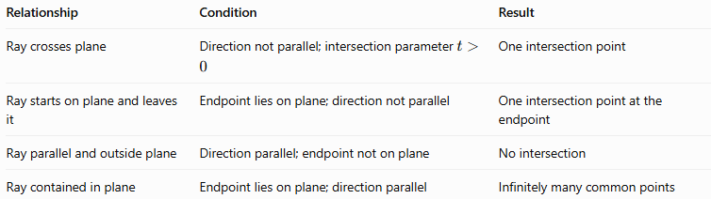
Relationship | Condition | Result
Ray crosses plane | Direction not parallel; intersection parameter $t>0$ | One intersection point
Ray starts on plane and leaves it | Endpoint lies on plane; direction not parallel | One intersection point at the endpoint
Ray parallel and outside plane | Direction parallel; endpoint not on plane | No intersection
Ray contained in plane | Endpoint lies on plane; direction parallel | Infinitely many common points

Practical applications
# Source: AI Source: Provided by: [Data Path: Persons Table -> ID Column: 1, Name_En Column: Motasem Essam] -> From: [ChatGPT] on [7/25/2026]
- Computer graphics: determining where a ray from a camera intersects a modeled surface.
- Optics: calculating where a light ray reaches a flat mirror or screen.
- Engineering: finding where a directed path meets a planar component.
- Robotics: checking whether a projected trajectory reaches a flat obstacle.
- Geometric modeling: calculating intersections between rays and faces of three-dimensional objects.

Key points
# Source: AI Source: Provided by: [Data Path: Persons Table -> ID Column: 1, Name_En Column: Motasem Essam] -> From: [ChatGPT] on [7/25/2026]
- A ray intersects a plane when they share at least one point.
- A nonparallel ray intersects a plane at exactly one point.
- A ray can meet the plane at its endpoint.
- A ray parallel to and outside a plane has no intersection with it.
- A ray contained in a plane shares infinitely many points with that plane.
- The ray parameter must satisfy $t≥0$ for the intersection to belong to the ray.

Conclusion
# Source: AI Source: Provided by: [Data Path: Persons Table -> ID Column: 1, Name_En Column: Motasem Essam] -> From: [ChatGPT] on [7/25/2026]
A ray intersecting a plane describes how a one-directional path meets a flat surface in three-dimensional space. Using the vector equation of the ray and the equation of the plane makes it possible to determine whether they intersect, find the intersection point, or establish that they are parallel or contained in one another.

